Leading change | Sharon Justice  Justice Leadership

Why Change?
Everyone faces change. Sometimes we face multiple changes everyday. Why do some of us “go with the flow” while others seem to agonize every decision and possible change? Why do some people seem to vacillate between liking some change and resisting other change? It’s all rooted deep in our personality and our behaviors. We have each learned about change and how to respond to change since the day we were born. This session will seek to dive deeper into our own personal reactions when faced with a change, how those reactions impact those around us. We will also take a look at the stages of transition and how we can lead others in the often difficult transitions of the changes we are faced with.

Follow the instructions as given. Write your answers in the space below.
Reflect:- How did these changes make you feel about yourself?
- Did you ask for help when you were going through stress caused by changes?
- What thoughts came up as you experienced these changes?
- Do you feel that you were able to adapt quickly or more slowly to the changes that you were asked to make?
- Were your responses to these exercises typical of how you respond to change?

Activity:
What is a change that is planned or has already begun? Describe it:
______________________________________________________________________________
What concerns you most about this change?
______________________________________________________________________________
What is your role in the change?
______________________________________________________________________________
Who will you have to help navigate through the change? ______________________________________________________________________________
Name the people that are impacted as a result of this change within your workplace. ______________________________________________________________________________
What are some of their reactions to the change (or if it isn’t announced yet, what do you anticipate their reaction to be?) ______________________________________________________________________________

What is Change Style Indicator
Do not repeat the tactics which have gained you one victory, but let your methods be regulated by the infinite variety of circumstances.
Sun Tzu

Describe your Change
Indicate on the chart the rate and intensity of change you are experiencing.

Dimensions of Change
There are 2 dimensions of every change that we face: Structure and Response: The structural event simply means the actual event that causes you to change. The Response to the event is the process by which we adjust to the new situation.

The CSI Continuum
 | Conserver |  |  |  | Pragmatist |  |  |  |  | Originator
 | 60 | 30 | 17 | 9 | 5 | 0 | 5 | 9 | 17 | 30 | 60
There are three styles that make up the CSI.
The results of your CSI will place you on a continuum ranging from the Conserver style to an Originator style with the Pragmatist style occupying the middle of the continuum.

The closer to the end of the continuum, the stronger the preference for a conserver or originator approach to change.

Change Style Survey
Instructions:

Distribute a Total of 3 Points to each PAIR of statements.

Depending upon on how strongly you agree with each statement A or B, assign the statement 0,1,2 or 3.
0=Almost never
1=Sometimes
2=Often
3=Almost Always

Total for each pair must equal 3
A 2 | I value originality
B 1 | I value practicality

Remember to respond as you think you are not as you want to be.

Once complete, put your answers into the scoring grid on the next page.
1 | A | I am good at generating new ideas
 | B | I am good at building upon existing ideas
2 | A | I become bored easily with routine tasks
 | B | I can perform long detailed tasks without boredom
3 | A | I am good with details
 | B | I can see the big picture
4 | A | I like to work on practical problems
 | B | I like to work on theoretical problems
5 | A | I value originality
 | B | I value practicality
6 | A | I prefer to follow the book
 | B | I prefer to make it up as I go along
7 | A | I like to tryout new and untried solutions
 | B | I like to try practical solutions
8 | A | I prefer to work on one project at a time
 | B | I prefer to work on several projects simultaneously
9 | A | I produce many ideas, some of which may be unworkable
 | B | I produce a few relevant and proven ideas
10 | A | I believe policies should be challenged
 | B | I believe policies should be followed
11 | A | I promote harmony in groups
 | B | I promote the sharing of different opinions in groups
12 | A | I bend the rules
 | B | I abide by the rules
13 | A | I seek familiarity
 | B | I seek adventure
14 | A | I complete projects in a roundabout way
 | B | I complete projects in a step-by-step fashion
15 | A | I like doing things in a familiar way
 | B | I like doing things differently each time
16 | A | I like to hand off a project once I know it can be done
 | B | I like to follow a project through to the end
17 | A | I prefer creating something new
 | B | I prefer improving upon something that already exists
18 | A | I appreciate tradition
 | B | I appreciate change
19 | A | I like work on cutting edge issues
 | B | I like working on relevant day to day issues
20 | A | I make decision based on actual fact
 | B | I make decision based on my intuition
21 | A | I prefer written instructions
 | B | I prefer picture instructions
22 | A | I respond to situation sin a measured way
 | B | I respond to situations spontaneously

Change Style Survey Scoring
Instructions: Step 1: Using your answer key, write in the value you entered for each answer, for each question.
Question
1 | A | B
2 | A | B
3 | A | B
4 | A | B
5 | A | B
6 | A | B
7 | A | B
8 | A | B
9 | A | B
10 | A | B
11 | A | B
12 | A | B
13 | A | B
14 | A | B
15 | A | B
16 | A | B
17 | A | B
18 | A | B
19 | A | B
20 | A | B
21 | A | B
22 | A | B

Carefully total your answers: Don’t simply add the columns. Add the shaded and non shaded boxes.
Step 2: Total your responses below
Total
 | Shaded (Conserver) | Not Shaded (Originator)
Step 3: Calculate the difference:
Circle Which was larger: Shaded (C) or Not Shaded (O)
Step 4: Plot your score on the next page
Example:
44 | 22
Shaded Conserver | Not Shaded Originator
44-22=22 (Shaded-Conserver)
.

Style Descriptions

CONSERVERS prefer the known to the unknown. The goal of a Conserver is to improve effectiveness by more efficiently utilizing resources – people, technology, knowledge and capital. Conservers prefer change that is gradual and incremental. The Conserver style advocates for continuous improvement while minimizing chaos and uncertainty. Conservers prefer to work within existing rules and policies.

PRAGMATISTS prefer to explore the current situation in an objective manner. They are likely to advocate for change that is reflective of the demands and constraints of the current circumstance, regardless of the impact on existing rules, policy and structure. Pragmatists prefer change that is functional. While they are able to see multiple perspectives, they are most interested in what will work and seems most practical. However, the more a Pragmatist score moves toward either the Conserver or Originator side of the continuum, the more they will
express a change style reflective of that orientation.
ORIGINATORS prefer a faster and more radical approach to change. The preference of Originators is significant and expansive change, which occurs quickly. The preference of an Originator is to challenge existing rules, politics and structures, resulting in fast, fundamentally different, even disruptive changes. Originators typically challenge the status quo.

 | Conserver |  |  |  | Pragmatist |  |  |  |  | Originator
 | 60 | 30 | 17 | 9 | 5 | 0 | 5 | 9 | 17 | 30 | 60

SHADED NOT SHADED

The three styles described are to some degree artificially discrete profiles on a continuum that is not really as discrete when you apply it to every person in reality. The transition from one style to the next is gradual at best and has “gray” areas where description and behaviors are less predictable. There is not a clean break from one style preference to another!

Over 35,000 people have completed the CSI and it is found in the general population - 25% who complete the CSI score as a Conserver; 50% are Pragmatists and 25% are Originators

Conserver Change Style Preference
People with a Conserver preference may appear disciplined, detailed, deliberate, and organized. They know the rules, regulations, and policies of their domain and prefer change that adheres to them. For the Conserver, rules and regulations have inherent value, for without them the world would have no order, resulting in chaos. Conservers like to protect and preserve the resources of their organizations. They prefer thoughtful and well-reasoned change. Conservers understand the mechanics of getting things done and can use that knowledge to facilitate change they believe to be in the best interest of their team or existing organizational culture.

When Facing Change Prefer change that maintains the integrity of the current structure. May operate from conventional assumptions. Enjoy predictability. May appear cautious and inflexible. May focus on details and the routine

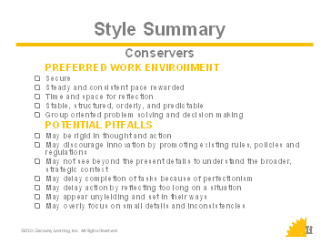
When Contributing to the Organization Get things done on schedule. Work well within organizational structure and constraints. Attend to detail and factual information. Demonstrate strong follow-through skills. Encourage and adhere to proven processes. Protect and manage the organization’s resources. Handle day-to-day operations with efficiency

When Leading Lead through reliable, stable, and consistent behavior. Reward following the norms while getting the job done. Attend to practical organizational needs. Expect organizational policies, procedures, and rules to be followed. Promote the traditional values of the organization

When Supporting Innovation Skilled at taking a new idea or concept Skilled at taking ideas and creating a plan for implementation. Attend to detail and will follow through until implementation is completed. Ensure desired results are obtained

When Collaborating Resist decisions that create chaos. Encourage building on what is already working. Focus on agreed upon goals and objectives.

Pragmatist Change Style Preference
People with a Pragmatist preference may appear reasonable, practical, agreeable, and flexible. Pragmatists tend to solve problems in ways that emphasize practical, workable outcomes. They understand and respect rules and policies but are not overly constrained by them. Pragmatists may appear more team oriented than either Conservers or Originators. While Conservers and Originators are working to preserve or challenge the status quo, Pragmatists are exploring the most effective means of addressing a problem regardless of the effect on the status quo. If goals can be met by working within existing structure, that will be their first choice; it’s faster. If fine-tuning does not work, they are comfortable with bigger change. Pragmatists typically can see both sides of an argument and often serve as mediators or “bridges” between Conservers and Originators.

When Facing Change Prefer change that emphasizes workable outcomes Are more focused on results than structure Are open to both sides of an argument Operate as mediators and catalysts on a team May take more of a middle-of-the-road approach Appear more team-oriented

When Contributing to the Organization Get things done in spite of rules, not because of them Negotiate and encourage cooperation and compromise to get problems solved Take a realistic and practical approach Draw people together around a common purpose Organize ideas into action plans Promote practical organizational structure

When Leading Facilitate problem solving among people Adapt past experiences to solve current problems Build cooperation rather than expecting it Use a facilitative approach to manage projects Encourage the organization to have congruence between values and actions.

When Supporting Innovations killed at taking a new idea or concept and bringing it into reality, making it tangible and concrete Bridge long-range goals with short-term demands Able to keep others focused and moving toward the end goal

When Collaborating Serve as Bridgers between diverse positions and opinions Encourage building upon multiple perspectives Focus on consensus

Originator Change Style Preference
People with an Originator preference may appear unconventional, spontaneous and lacking organization. They frequently attempt to solve problems in ways that challenge existing structure. Tradition and history are of less value than future possibilities. Originators prefer quick and expansive change. They are divergent thinkers and often generate many new ideas. Originators do not enjoy repetitive tasks and will look for a new or different way to do a job, whether needed or not. Originators are often described as risk-takers and may be viewed as the quintessential change agent. They will readily challenge the status quo and may even view the status quo as the problem.

When Facing Change Prefer change that challenges current structure Will challenge accepted assumptions Enjoy risk and uncertainty. May appear impractical and sometimes miss important details. May appear more future than past-oriented. Can treat accepted policies and procedures with little regard
When Contributing to the Organization Push the organization to see the big picture. Provide future-oriented perspectives for the organization. Support and encourage risk-taking behavior. Promote new ideas, projects and activities. Enjoy complex problems. Think conceptually
When Leading Serve as catalysts for big change. Can be energetic and enthusiastic. Provide long-range perspective. Conceptualize and design new processes that reorganize the whole system. Like to be in charge of the start-up phase
When Supporting Innovation Not afraid to challenge the status quo. Encourage exploration of new and alternative ideas. Can present possibilities that others do not imagine. Produce many divergent ideas
When Collaborating Encourage out-of-the-box thinking. Initiate enthusiasm and excitement. Focus on initiating new tasks.

Personal Reflection

What do we need to know around working effectively with you and your style?
________________________________________________________________________________________________________________________________________________________________________________________________________________________________________________________________________
What frustrates you about working with other styles?
________________________________________________________________________________________________________________________________________________________________________________________________________________________________________________________________________

What tips would you offer to work together more effectively?
________________________________________________________________________________________________________________________________________________________________________________________________________________________________________________________________________

Perceptions

Flexing Your Style
Assessing how you can meet another style from their viewpoint can help you be much more successful in your personal interactions. When you are facing change, take a moment to evaluate how styles may react.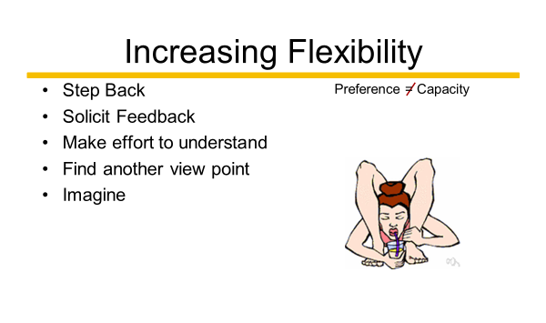

- What actions would you like to try?

Working Together

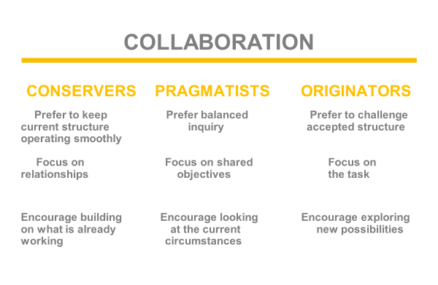
A variety of styles can add an enriching experience for everyone in your organization. Ensuring that teams and groups have a diverse set of styles represented can allow your team to be more effective. Whether you are seeking to be more open and change oriented, if you need to slow down a bit and consider the impacts of change, or seek a perspective to keep it all balanced, consider the changes styles when working together and forming teams or workgroups.

Identify the styles of your team, workgroup, or committee.

- Do you have all styles?
- Are you missing a style?
- How do you work together?
- Can you see the styles in action?

