Brown Family Farm Vision/Mission Statement

Vision is where BFF aspires to be (the top of the pyramid).
Vision answers  - What do we want the farm to become?  - What will be different in 5-10+ years?  - What will we be known for?  - How will the next generation fit in? | It is the “North Star” you use when deciding  - Buy land or lease?  - Raise cattle or sell it off?  - Add a value-added segment?  - Invest in irrigation/storage/technology?  - Bring in the next generation and how?

Example Vision that may fit the BFF:
“Become a resilient, multi-enterprise family farm recognized for profitable production, sustainable practices, and a successful next-generation transition.”

Mission is what you do now, for whom, and why it matters.
Mission is the farm’s day-to-day purpose, and it answers
- Who do we serve? (buyers, processors, local community, landowners, family)
- What do we produce or provide? (crops, cattle, tobacco, packing services, value-added)
- How do we do it? (quality, reliability, stewardship, efficiency, safety)
- Why does it matter? (feed people, support local ag economy, sustain the family legacy)

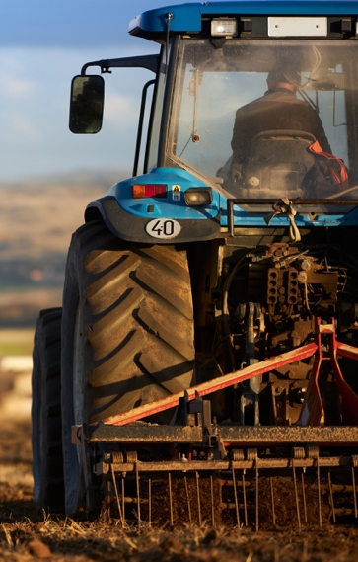
Example Mission that may fit the BFF:
“Produce reliable, high-quality crops and livestock while stewarding our land, supporting our community, and sustaining our family operation.”

Troubleshooting with the “Tractor Cab” test
Vision = Where we want the farm to be when our tractor is worn out.
Mission = Why we climb into the tractor today.

Ideas for BFF Vision/Mission sets
 | Rough Draft Version | Refined Final Version
Vision  1 | Build a resilient, multi-enterprise farm that stays profitable through volatile markets and weather, successfully transitions to the next generation, and is known for reliability and integrity. | A farm that stays profitable in good years and bad, earns a strong reputation, and is ready for the next generation.
Mission  1 | Grow and deliver high-quality crops efficiently and safely, while stewarding our land, supporting our people, and sustaining the Brown family legacy. | Grow good crops and run the farm well, take care of the land and our people, and keep the farm strong for the Brown family.
Vision  2 | Shift from commodity dependence to a customer-driven portfolio where sweet potatoes and produce channels, packaging, and targeted markets reduce waste and increase margins. | A farm that makes more money by selling into better markets, using packing and smart outlets to cut waste and rely less on commodity prices.
Mission  2 | Produce and pack crops that meet customer specs with consistent quality and food-safety discipline, earning premiums by being the easiest supplier to buy from. | Grow and pack crops that meet buyer needs every time, with dependable quality and safe handling.
Vision  3 | Create a scalable operation with modern management systems and leadership depth, where family owners earn fair returns and the farm can grow without overwhelming the people running it. | A farm that can grow without chaos, with strong systems and good leaders, and fair returns for the family owners.
Mission  3 | Operate Brown Family Farm as a coordinated set of businesses, aligning family and non-family talent around clear roles, strong controls, and performance by enterprise. | Run the farm like a set of businesses, with clear jobs, clear decisions, and clear numbers for each part of the operation.

