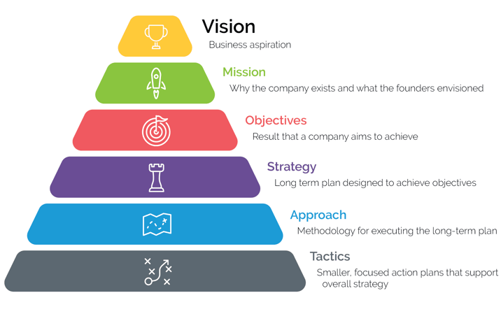
Source: Dan Overgaag, Spur Reply Consulting

Vision:

Mission:

Objectives:

Strategy(ies):

 | Vision: To enrich the lives of those who produce and those who consume, ensuring progress for generations to come.  Mission: A global pure-play agriculture company that combines industry-leading innovation, high-touch customer engagement and operational execution to profitably deliver solutions for the world's most pressing agriculture challenges.
 | Vision: Engage, delight and inspire consumers by building brands they love and leading in growing categories. Our Vision is our long-term direction that guides business priorities and aligns our organization.  Mission: Maintain a relentless focus on the consumer and stay empowered by the pillars of driving prioritization and best-in-class execution, improving profitability and cost discipline, and nurturing and investing in our culture.
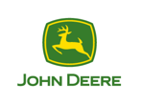 | Vision: Conduct business essential to life. Running for the people who trust us and the planet that sustains us, we create intelligent connected machines that enable lives to leap forward.  Mission: Create tech for farmers and builders. Innovate on behalf of humanity.
 | Vision: Be the premier purveyor of the finest coffee in the world, inspiring, and nurturing the human spirit – one person, one cup and one neighborhood at a time.  Mission: Commitment to source, roast and serve the highest quality coffee and bring people together to inspire and nurture the human spirit.
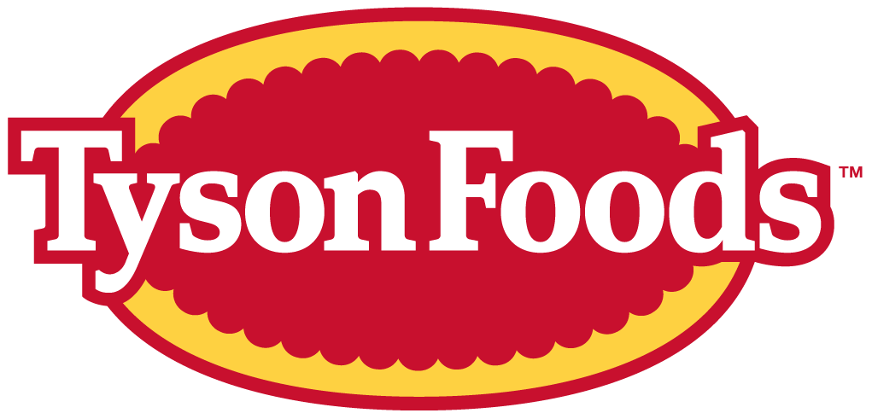 | Vision: Feed the world like family.  Mission: We are a company of people engaged in the production of food, seeking to pursue truth and integrity, and committed to creating value for our shareholders, our customers, our team members, and our communities.
 | Vision: Be THE destination for customers to save money, no matter how they want to shop.  Mission: Create shared value for customers, associates, suppliers, communities, and the planet. As a people-led, tech-powered omnichannel retailer, we focus on providing convenient, affordable, quality goods and services worldwide.

Examples of Business Strategies that create VALUE
Cross-sell more products – McDonald’s: “Do you want fries with that?”
Superior customer service – Chick-fil-A: “My pleasure”
Technologically advanced – Apple: iPod, iPhone, iPad, Smart Watch, …
Customer loyalty/retention – Amazon Prime: Subscription (Alexa, Audible, …)
Low-cost provider – Walmart: consistently low prices across bundles of goods

Business Model Definition (source: StrategyzerAG)
A business model describes the rationale of how an organization creates, delivers, and captures VALUE.

S.W.O.T. Analysis –Questions to Consider and Answer (source: StrategyzerAG)

Strengths/Weaknesses (Internal)

- Are our customers satisfied?
- Do we have complaints from customers?
- Do our products/services align with customer needs and preferences?
- Do we have strong relationships with our customers?
- Have we identified our ideal customer(s) and know our target market?
- How are our margins?
- Are revenues predictable?
- Are our customers loyal (repeat purchases)?
- Is our revenue stream diversified and sustainable?
- Are there products or enterprises that are underperforming?
- How is our cash flow?
- Do we have enough working capital to get through times of deficits in cash flow?
- Are our prices based on value and customer willingness to pay?
- Are costs predictable?
- Do we benefit from economies of scale (utilizing assets fully)?
- Are our operations cost-efficient?
- Do we have a competitive advantage?
- Are our resource needs predictable?
- Do we have the resources to implement our strategies (human/financial capital, infrastructure)?
- Do we have partners along the supply chain?

Threats (External)

- Are competitors threatening to offer better prices or value?
- Are there substitute products available?
- Are margins threatened by technology, regulations, competition, policy?
- Are we in danger of losing partners along the supply chain?
- Do we risk losing partners to collaboration with the competition?
- Is competition threatening market share?
- Do we rely on one revenue stream more than others?
- Could our market be saturated soon?
- Is there a revenue stream that is likely to disappear in the future?
- Which costs threaten to become unpredictable?
- Which costs threaten to grow more rapidly than revenues?
- Could we face a disruption of supply, or quality, of resources?
- How likely are our relationships with customers to deteriorate and for them to defect?

Opportunities (External)

- Can we generate recurring revenue by converting products into services?
- Can we meet other customer needs?
- Can we increase prices?
- Where can we reduce costs?
- Have we identified and “fired” unprofitable customers? If not, why not?
- Can we serve a new group of customers?
- Can we improve personalization?
- How can we improve efficiency?
- Can we cross-sell, what other products would customers be willing to buy?
- What resources would be better sourced from partners along the supply chain?
- Can we increase margins by directly serving customers?
- How can we benefit from a growing market?
- Can we strengthen customer relationships with more touch points?
S.W.O.T. – Brown Family Farm

Internal
Strengths | Weaknesses

External
Opportunities | Threats
Pains
Jobs to be Done
BFF Jobs to be Done
Jobs describe the things your customers are trying to get done in their work or in their life.

A customer job could be:
- the tasks they are trying to perform and complete,
- the problems they are trying to solve, or
- the needs they are trying to satisfy.

Customers “hire” businesses to do three types of jobs for them:

Functional  Jobs | Personal/  Emotional  Jobs | Social  Jobs
Customers desire to complete a task or solve a problem.  - Tangible  - Measurable  - Actionable | Customers seek an emotional state such as feeling secure or satisfied.  - Insecurities  - Preferences  - Relationships | Customers want to be seen by others through status, relationships, or positions of power.  - Brand  - Fashion  - ESG

Instead of seeing the world through the lens of what the company is doing (products & services), see the world through the lens of what the customer is trying to get done.

Harvard Business School marketing professor Theodore Levitt said, "People don't want a quarter-inch drill; they want a quarter-inch hole."

Sources: StrategyzerAG and Tony Ulwick, pioneer Jobs-to-be-Done Theory

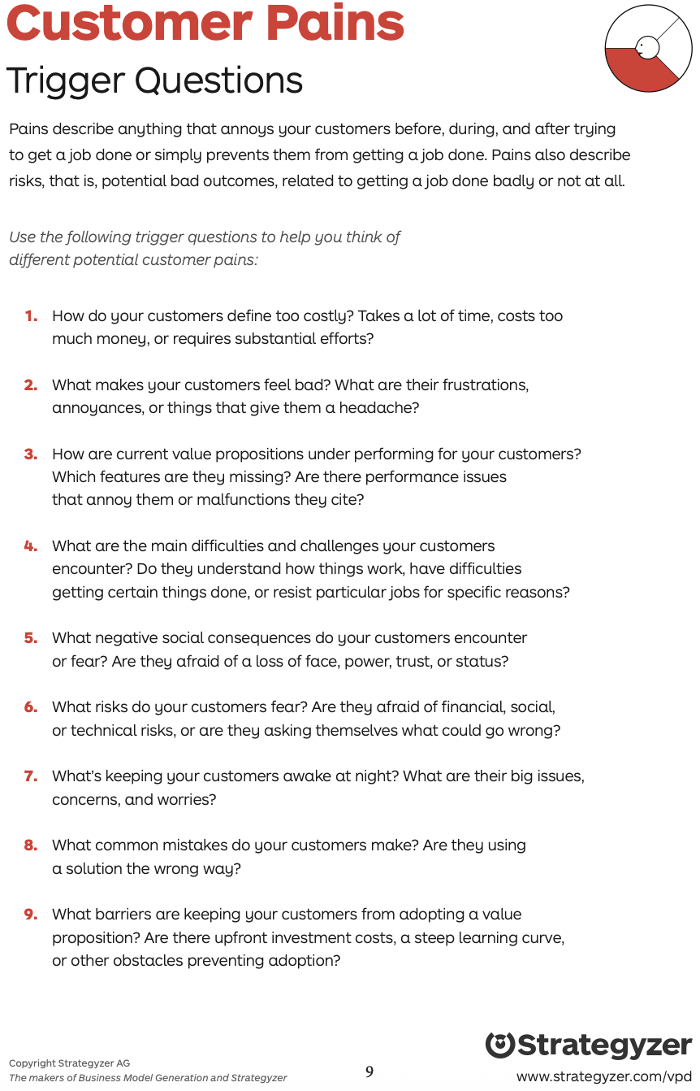
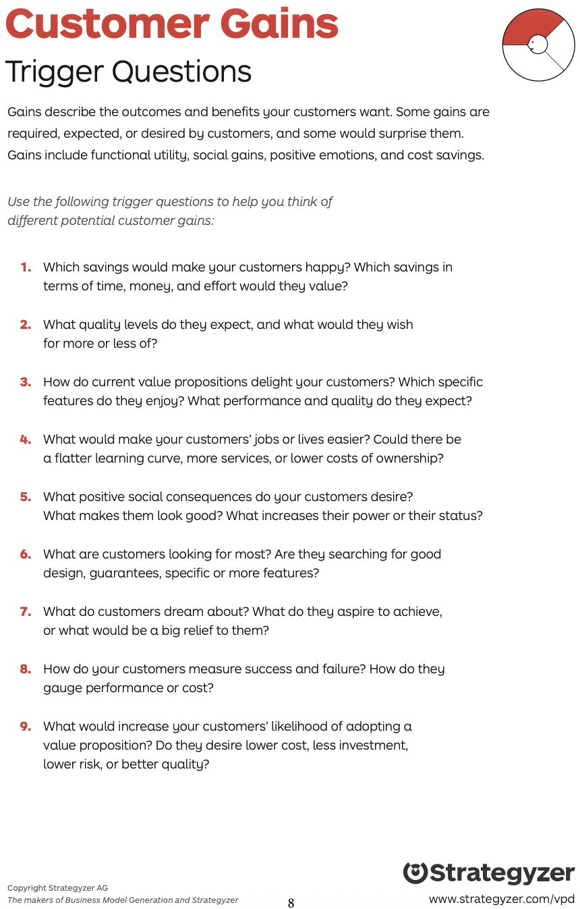
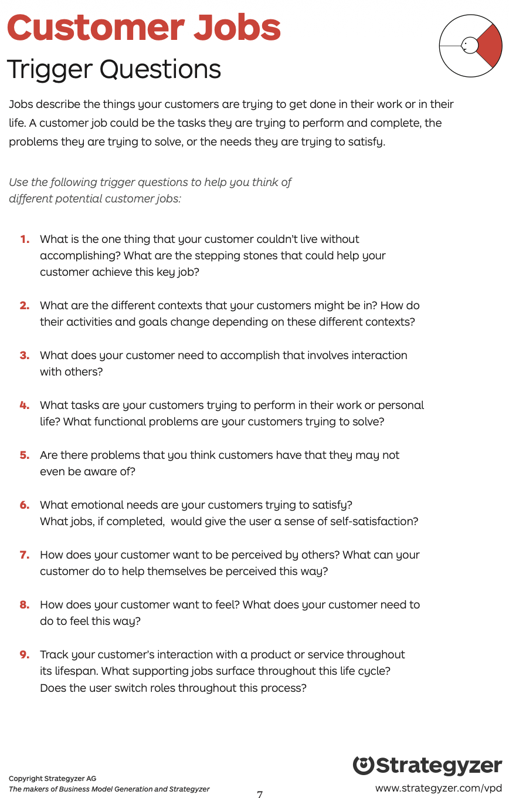
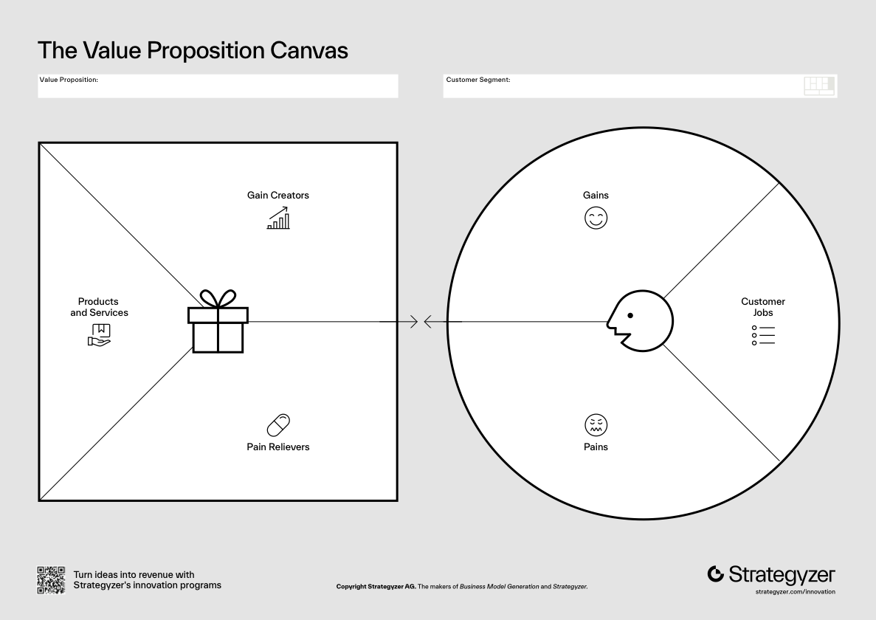
BFF Value Proposition Map

Products & Services |  | Gain Creators
 |  | Pain Relievers

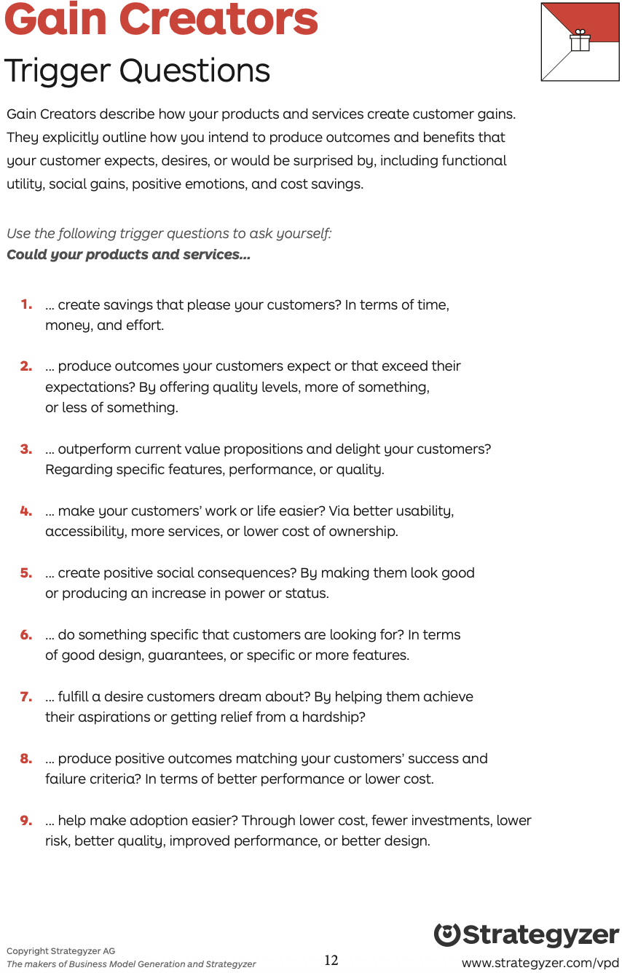
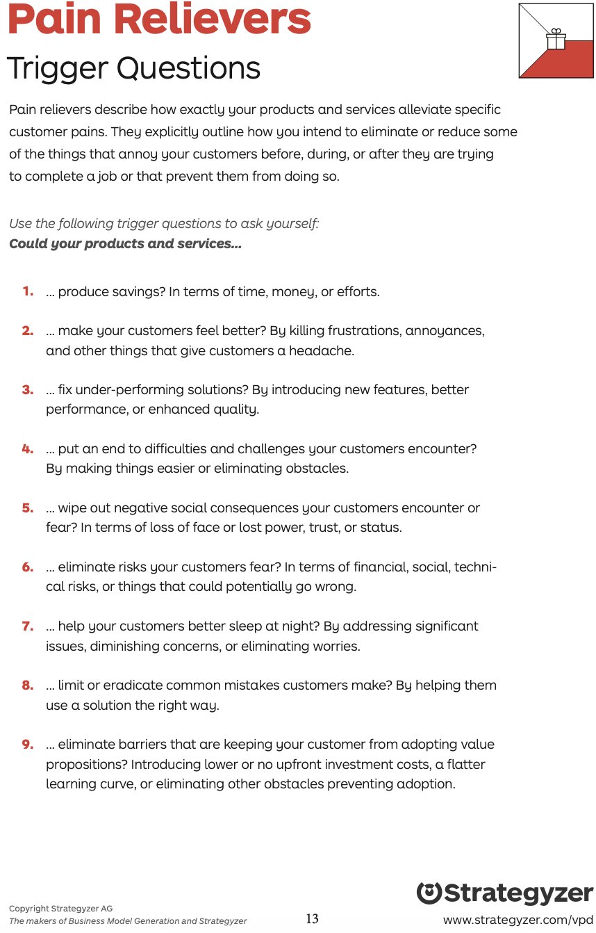
BFF Value Propositions (source: Lisa DeCarlo, Just GO)

- What are the current value propositions for the BFF?
- What could they be in the FUTURE?
- What value do we deliver to the customer?
- Which of the customer’s problems are we helping to solve?
- Which customer needs are we satisfying?
- What bundles of products and services are we offering to each customer segment?

Current  Value Propositions | Future  Value Propositions
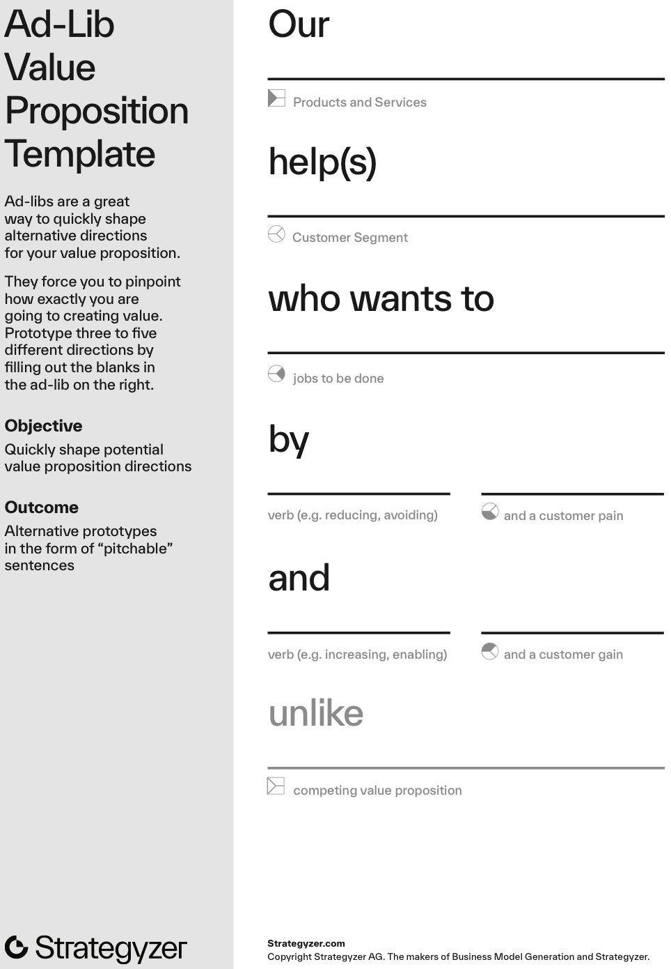
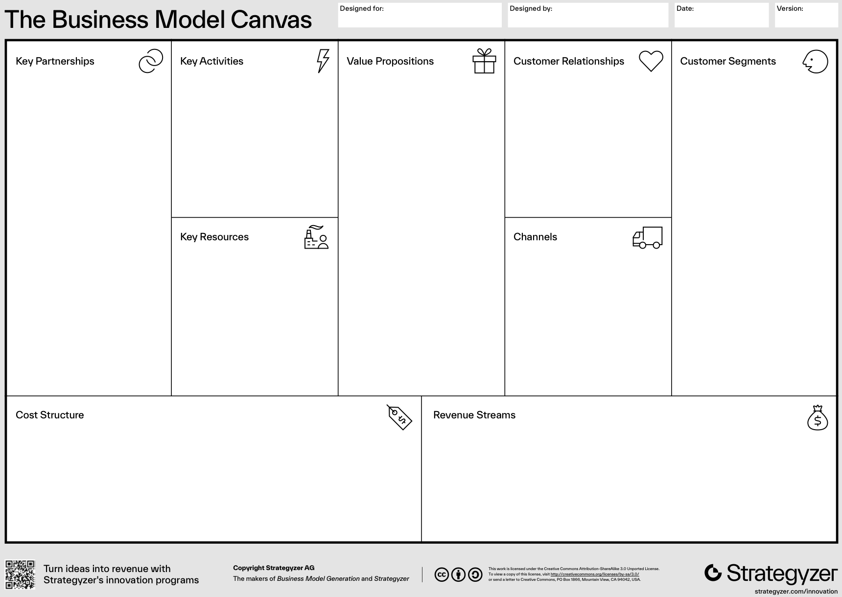
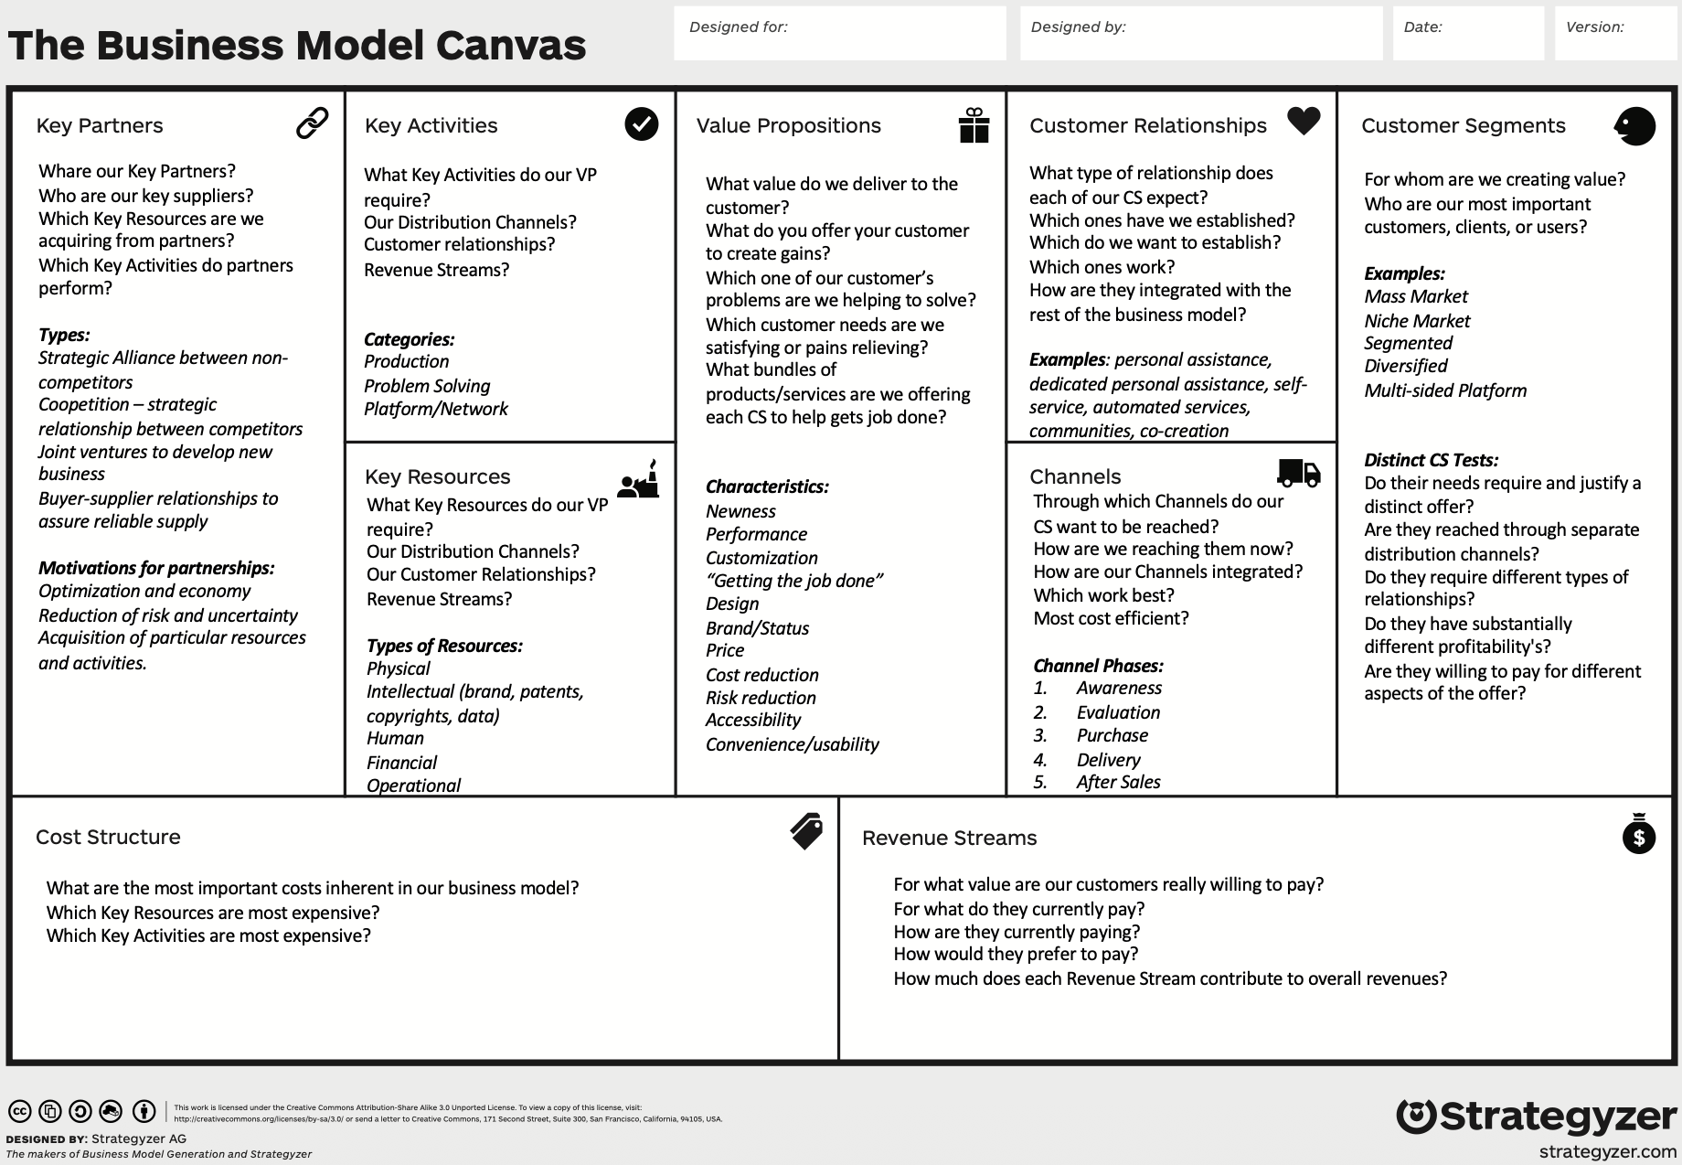
BFF Customer Relationships

Categories of relationships (sources: SolutionsHub and Lisa DeCarlo, JustGO):
- Dedicated personal assistance/Advisory (crop consultant)
- Automated service (automatic bill pay)
- Community exchange (online forum for shared learning)
- Co-creation/Collaborative (crowdsourcing)
- Self-service (tech driven, empower customers with online portals)
- Transactional (selling commodities)
- Subscription (monthly produce box)
- Assured quality (warranty/guarantee)
- What kind of relationship do our customers expect?
- Which relationships have we established?
- Which relationships do we want to establish?
- Which relationships work?
- How costly are the relationships?

BFF Customer Channels (source: Lisa DeCarlo, JustGO)

Direct examples
- Sales force
- Website
- Stores
Indirect examples
- Wholesaler
- Partner stores
- Partner website

- How do we touch our clients/segments?
- Which channel do our customer segments want to be reached?
- How are we reaching them now?
- How are the channels integrated?
- Which work best?
- Which are most cost-efficient?

Phases | Channel
Awareness
Evaluation
Purchase
Delivery
After Sales
BFF Resources/Activities/Partners (source: Lisa DeCarlo, JustGO)

Partnerships/Suppliers |  | Resources
- Strategic alliances between non-competitors  - Co-opetition: strategic relationship between competitors  - Joint ventures to develop mew business  - Buyer-supplier relationships to assure reliable supply |  | - Human, operational, physical, intellectual, financial
 |  | Activities
 |  | - Production (manufacturing, problem solving (consulting, hospitals), platform/network (eBay, Microsoft)

